Public Transportation Efficiency Analysis

What if:

Public transport is a system of transport for passengers by group travel systems available for use by the general public unlike private transport, so passenger feedback and supporting improvement transportation.

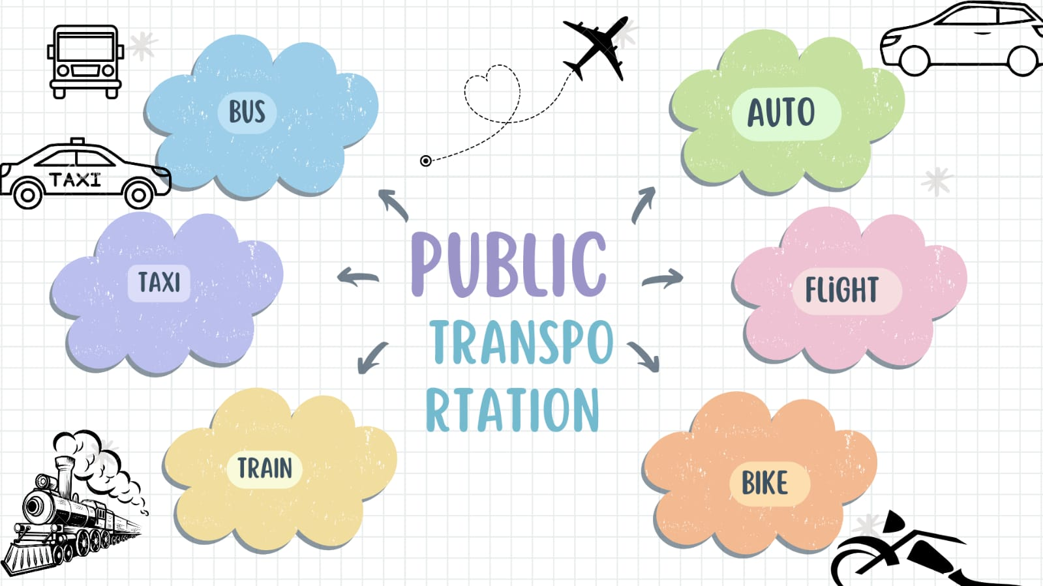

1.DAC Project in Public Transport:

**Data Analytics with Cognos** projects that have been implemented in public transport systems, including smart ticketing, real-time passenger information systems, and automated fleet management.

The Importance of Predicting Arrival Time:

Learn why accurately predicting arrival times is crucial for passengers, operators, and city planners. data analysis techniques can help optimize scheduling and reduce delays.

Data Collection and Analysis Methods ;

* Big Data Analytics:
* Explore the use of advanced analytics techniques to process and analyze massive datasets, unlocking valuable insights for optimizing public transport operations.
* Machine Learning
* Discover how machine learning algorithms can be trained on historical data to recognize patterns and predict arrival times with greater accuracy.
* Time Series Analysis
* Learn how statistical techniques can analyze historical data to identify temporal patterns and seasonality, facilitating precise arrival time predictions
* Real-Time Data Sync
* Discover how prediction models integrate with real-time data feeds from sensors and other sources, enabling dynamic adjustments to arrival time estimates
* Passenger Information Systems:
* See how arrival time predictions are seamlessly communicated to passengers through digital displays, mobile apps, and public announcements.
* Operational Decision Support
* Explore how transport operators use prediction models to optimize driver schedules, minimize waiting times, and improve the overall efficiency of their services.
* on-time performance

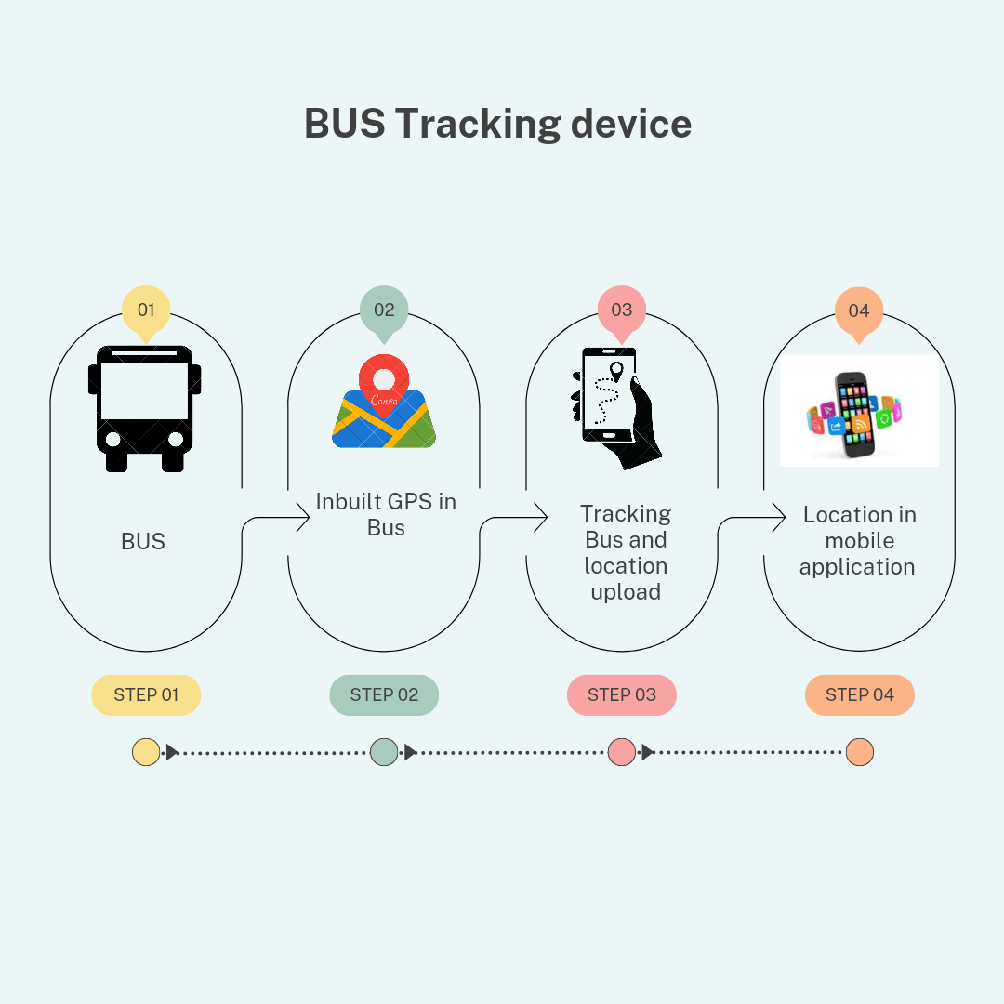

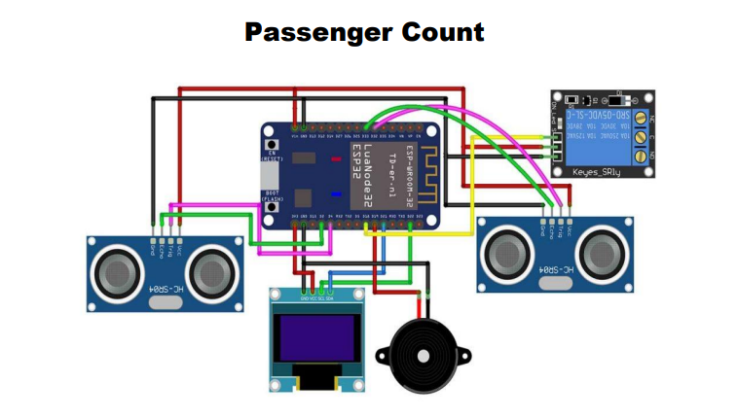

Program for Passenger Count

import time

import random

class Bus:

def __init__(self, bus_id):

self.bus_id = bus_id

self.location = 0

def move(self):

self.location += random.randint(1, 5)

def get_location(self):

return self.location

class Passenger:

def __init__(self, passenger_id, destination):

self.passenger_id = passenger_id

self.destination = destination

def request_bus_info(self):

# Simulate requesting bus information

print(f"Passenger {self.passenger_id}

is looking for a bus to {self.destination}.")

class BusStop:

def __init__(self, name, location):

self.name = name

self.location = location

def is_near(self, bus):

return abs(bus.get_location() - self.location) <= 2

def main():

# Create buses and bus stops

buses = [Bus(1), Bus(2)]

bus_stops = [BusStop("Stop A", 10), BusStop("Stop

B", 20)]

passengers = [Passenger(1, "Stop B"), Passenger(2,

"Stop A")]

while True:

for bus in buses:

bus.move() for passenger in passengers:

if passenger.request_bus_info():

for stop in bus_stops:

if stop.name == passenger.destination:

if stop.is_near(bus):

print(f"Bus {bus.bus_id} is approaching

{stop.name} for Passenger

{passenger.passenger_id}.")

time.sleep(1)

# Simulate time passing

if __name__ == "__main":

main()